Ideation Phase
Define the Problem Statements

Date | 30 September 2026
Team ID | SWTID-2026-2843
Project Name | AI-weather-wise API
Maximum Marks | 2 Marks

Customer Problem Statement:
As a customer, I often find it difficult to get accurate and reliable weather information for my location when I need it. Weather conditions can change quickly, and different sources may provide confusing or inconsistent information. I need a simple way to check the current temperature, humidity, rainfall chances, wind conditions, and upcoming weather forecasts. I also want timely alerts about severe weather so that I can prepare in advance. Without clear and location-specific weather information, it can be difficult to plan travel, outdoor activities, work, and daily routines safely and effectively.
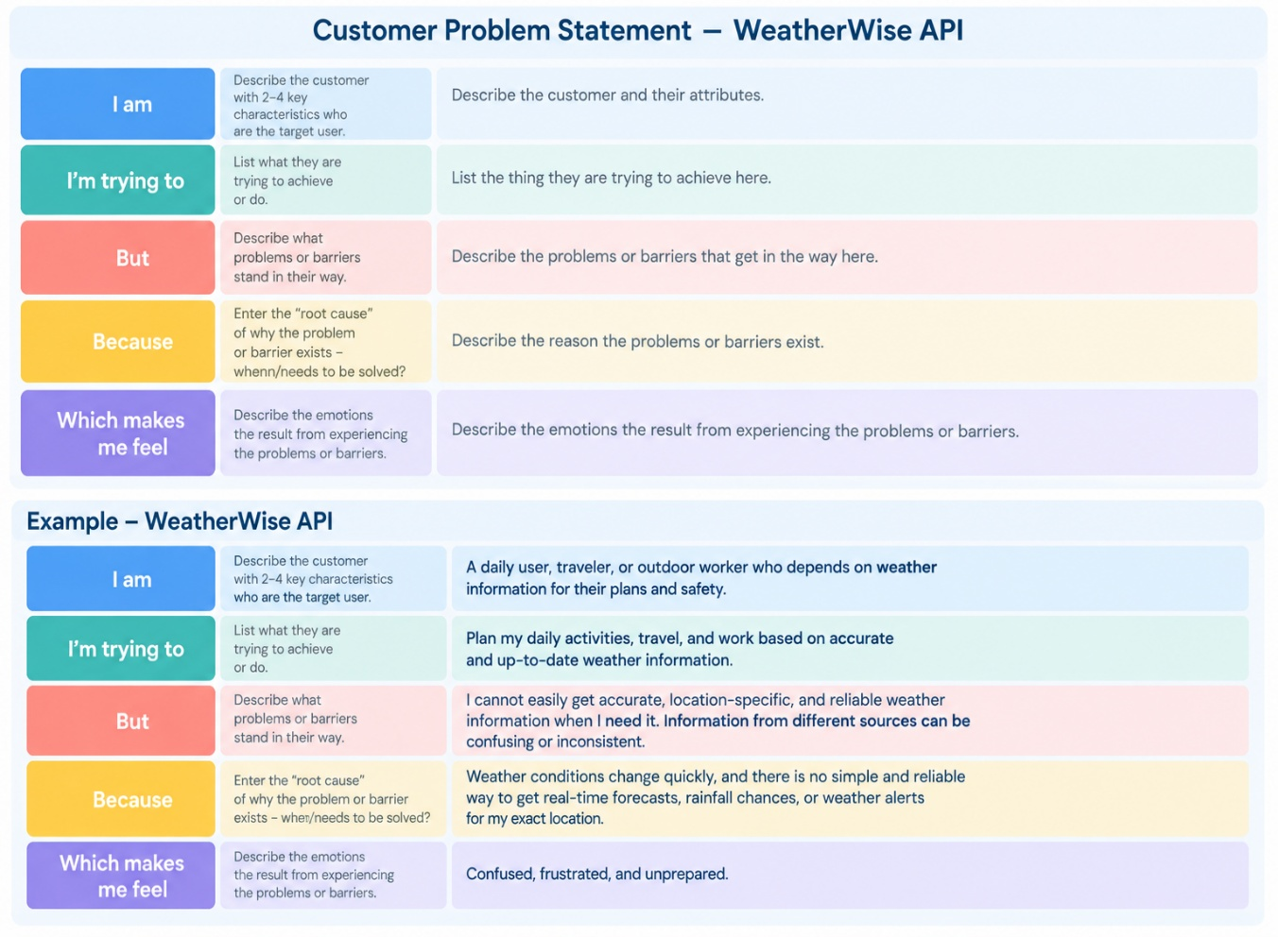

Problem Statement (PS) | I am (Customer) | I’m trying to | But | Because | Which makes me feel
PS-1 |  | Plan my daily activities based on the weather | cannot easily find accurate, location-specific weather information | Weather information can be confusing or inconsistent across different sources | Confused and frustrated
  A daily user
PS-2 | A traveler | Check the weather before traveling | I may not get timely forecasts or rain alerts | Weather conditions can change unexpectedly | Worried and unprepared

